Parvat Computer Technology
2024-2025
Weather APP
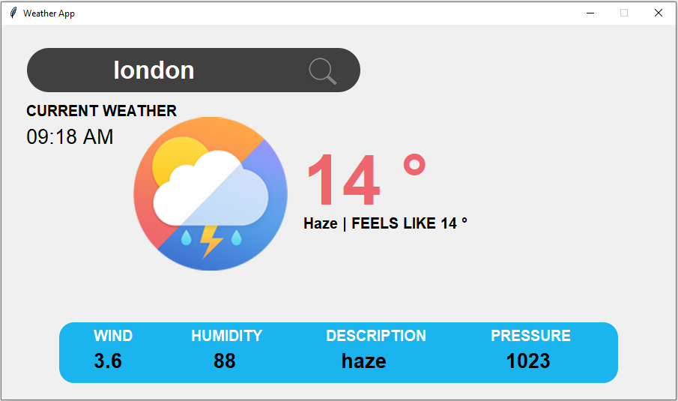
We can find weather reports such as temperature, humidity, pressure, wind speed and description etc. of any place in the world. You need to provide the name of a place. Not only this you will also get current time of that place.
Parvat Computer Technology
New Delhi
401002


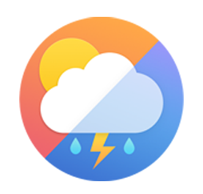
Your College Logo Your Institute Logo

Your College name Institute of Technology
Delhi-41327
Department of Computer Engineering
Academic Year 2024-25

Mini Project Report
On
Weather App using Python

Submitted by:
Student1 Name and Roll Number
Student2 Name and Roll Number
Student3 Name and Roll Number
Student4 Name and Roll Number

(Dr. Guide Name)
Guide

ABSTRACT
Python program to create a Weather Forecast Application using Python programing concepts and Tkinter GUI to develop application.
This is a project report on “WEATHER FORECASTING APPLICATION” using OpenWeatherMap API. It is a service that provides weather data, including current weather data. Forecasts and historical data to the developer of web services and mobile application. It provides an API with JSON, XML and HTML formats.
To use the current weather data API, users must first create an account on openweathermap.org in order to obtain an API key.
It is a set protocol, routines, functions and/or commands that programmers use to develop software or facilitate interaction between distinct systems. APIs are available for both desktop and mobile use, and are typically useful for programming GUI (graphics user interface) components, as well as allowing a software program to request and accommodate services from another program

Python GUI Tkinter:
Python presents several alternatives for developing Graphical User Interfaces (GUIs). Among all the available methods, tkinter is the most frequently used one. It is a standard interface in Python for the TK GUI toolkit that comes with Python. tkinter is the quickest and simplest way to create GUI applications. Creating a GUI using tkinter is a relatively easy task.
Introduction

Weather forecasting is the prediction of atmospheric conditions for a specific location and time. It involves using technology and scientific knowledge to make weather observations to predict things like cloud cover, rain, snow, wind speed, and temperature. It is important for businesses, farmers, disaster management organizations to understand natural phenomena. Weather forecasting contributes to social and economic welfare by providing vital information to various sectors. It can also significantly influence decision-making, productivity, and environmental risk management.

What is weather forecasting?

Weather is an important aspect of a person life as it can help us to know when it will rain and when it will be sunny. Weather forecasting is the attempt to predict the weather condition at some future time and the weather conditions that may be expected. The climatic condition parameters are based on the temperature, pressure, humidity, rainfall, precipitation, wind speed and size of data set. The parameters temperature, pressure, humidity, precipitation, rainfall is only considered for experimental analysis.
Weather forecasting is the application of science and technology to predict the conditions of the atmosphere for a given location and time. People have attempted to predict the weather informally for millennia. Weather forecasts are made by collecting quantitative data about the current state of the atmosphere, land, and ocean and using meteorology to project how the atmosphere will change at a given place.

Traditional Weather Forecasting methods

The traditional methods of weather forecasting, which are also known as weather lore, have been utilized by farmers, fishermen, and housewives to guide their daily activities and prepare for potential disasters. In the remote villages of 17 municipalities in Ilocos Norte, the weather lore used by the weather-wise folks is documented and shows that they have almost similar indicators for the onset of rainy season or adverse weather conditions. According to the respondents, the strange behavior of certain animals such as ants, earthworms, dragonflies, dogs, frogs, and birds like the Himalayan swiftlet, lesser caucal, plaintive cuckoo, heron, or honeybees usually predict upcoming rain, typhoon, or bad weather. Additionally, the ripening and shedding of fruits of plants such as physic nut, bangkal, and siniguelas were also considered by farmers as reliable indicators of the onset of rainy season. A long parallel band of feathery clouds and a moon with rings were also important clues to predict weather. For fishermen, visible seawater evaporation and high sea waves forecasting have been used for many years as handed down to them by their forefathers.

Requirement And Specification

Hardware Requirements:

PROCESSOR : Intel(R) Core (TM)i5-4300G1 CPU@1.90GHz ,2501 MHz
HARD DISK : 200 MB
RAM : 4GB

Software Requirements:
OPERATING SYSTEM : Window7/8/10/11 , Linux, Mac etc.
PROGRAMMING LANGUAGE : Python (version 3.10.5)
IDE USED : Visual Studio

Weather App Working

How to start:
It is quite easy to work with Openweather API. Just sign up to get your API key and then call any weather API. And mind using API call whatever account you choose from Free to Enterprise
How to start in 3 simple steps
1. Open Openweathermap
2. Sign up and get an API key (APPID) on your account page.
After registration, we will send you a welcome email that contains your API key and additional information on how to get started with our weather APIs. Within the next couple of hours, it will be activated and ready to use.
3. Start using API for free.
API call: "https://api.openweathermap.org/data”
Parameters:
APPID{APIKEY} is your unique API key
Example of API call: "https://api.openweathermap.org/data”
Python Weather Application using Tkinter

Python offers multiple options for developing GUI (Graphical User Interface). Out of all the GUI methods, tkinter is the most commonly used methods. It is a standard python interface to the Tk GUI toolkit shipped with Python. Python with tkinter outputs the fastest and easiest way to create the GUI applications. Now, it’s upto the imagination or necessity of developer, what he/she want to develop using this toolkit.
To create a tkinter:
- Importing the module - tkinter
- Create the main window (container)
- Add any number of widgets to the main window.
- Apply the event Tigger on the main window.
Let’s create a GUI based simple Real-time Weather detection application which can give Weather details of any cities.
Modules required:
Geopy
Timezonefiner
Pillow
Pytz
requests

Weather Application

How to start:
It is a quite easy work work with python , in this method we have used few advance libraries like tkinter, geopy, timezonefinder,request, pytz and pillow.

How to start in 3 simple steps
1. Open Terminal, and install all required modules .
- pip install geopy==2.2.0
- pip install timezonefinder==6.0.1
- pip install requests==2.31.0
- pip install pytz==2024.1
- pip install pillow==10.3.0
2. Then open python file with the help of IDE, or by double click on file.
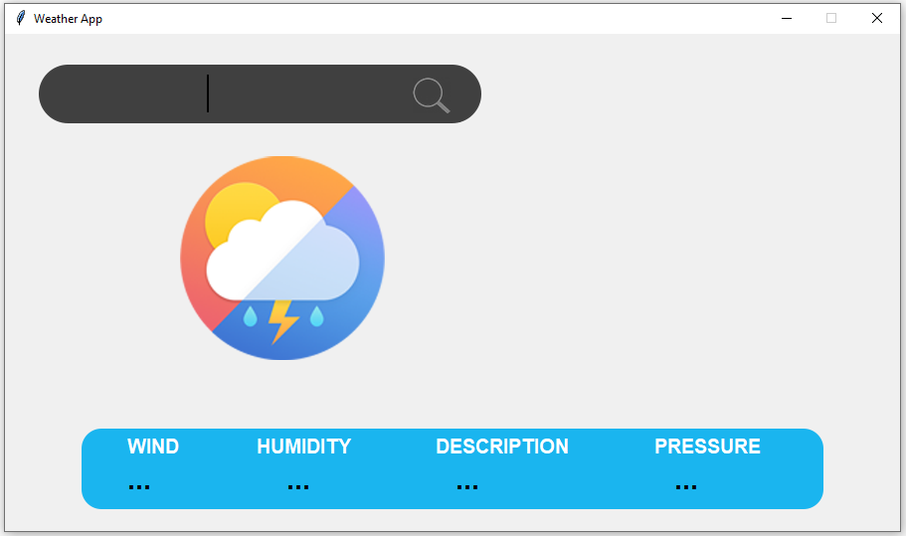

It is the first interface of Weather Application, which is completely design with the help of python tkinter.
It contain all the features with advance modules and working..
There is list of work we can perform , in this project:
- Temperature
- Humidity
- Pressure
- Wind Speed
- Description
- Time

3. Let’s start with input option:
Take *DELHI as input using Keyboard and press search icon 

Final Result:

Conclusion

The Project has been successfully completed by having established the user-friendly interface with the help of python tkinter library. Weather refers to day-to-day temperature and precipitation activity. It is the state of the atmosphere, describing the degree to which it is hot or cold, wet or dry, calm or stormy, clear or cloudy. Weather forecasts are increasingly accurate and useful, and their benefits extend widely across the economy. At the same time there is some scope for improvements in the future. This application is very helpful for the humans as it shows the weather details of a city.

Future scope:
- The complicated equation which govern how the state of fluid changes with time require super computer to solve them.
- The numerical weather prediction models are computer similuation of the atmosphere.
- The output from the model provides the basis of the weather forecast.
To develop a weather forecasting application on which people can completely rely for their weather updates. The scope for weather forecasting system will keep on increasing as the technology progresses.

